Subject: Your Worries are Over!
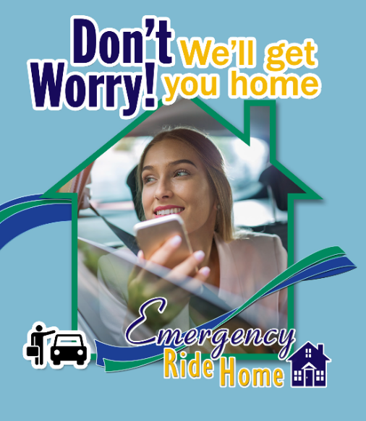
Good News! < Employer name> offers an Emergency Ride Home as a benefit for employees who carpool, use STA Rideshare (formerly vanpool), bus, bike, or walk to work and need to get home because of an emergency.
Free and Easy! If you need to get home in an emergency -- a family illness, unexpected overtime, or a missed ride -- just contact <name>, your Employee Transportation Coordinator. <He/She> will arrange a ride via <taxi and/or Lyft>so you can get home quickly. And the best news of all -- it's absolutely free!
Sit Back and Relax! For more information about the Emergency Ride Home Program, contact <ETC name> at <phone number>, today!

CommuteSmartNW.org

Subject: FREE Emergency Ride Home!
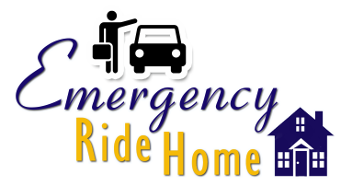
<Employer name> employees who use commute options to get to work will never be stranded at work in case of an emergency. As part of our Commute Smart program, we offer a free Emergency Ride home via taxi and/or Lyft.
If you carpool, use STA Rideshare (formerly vanpool), bus, bike, or walk to work, and have an emergency—a family illness, unexpected overtime, or a missed ride, this free and easy service is available to you.
Contact your Employee Transportation Coordinator <ETC name> at <phone number> for more information today!

CommuteSmartNW.org

