Subject: Score a Clean Air BINGO this Summer!
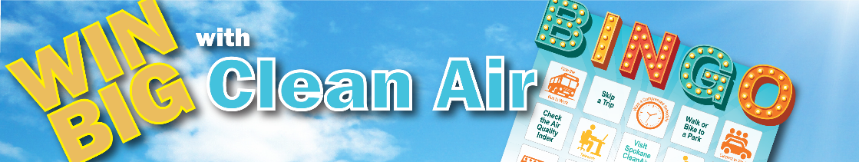 |  | Learn About Bad Ozone! While you're making efforts for cleaner air, it's a great time to understand "bad" ozone. Unlike the protective ozone layer high above us, ground-level ozone is a harmful air pollutant that forms on hot, sunny days from vehicle exhaust, industrial emissions, and other sources. It can impact on our respiratory health and is a key component of smog!
Get ready to breathe easier and win fantastic prizes with Clean Air BINGO this July, August, and September! In partnership with the Spokane Regional Clean Air Agency, we're making clean air fun and rewarding.
Play & Win: Every conscious choice you make for cleaner air, from carpooling to using electric yard equipment helps, and when you use a commute option, you could WIN some fantastic prizes!
- Monthly Grand Prize: $500 Cordless Electric Lawnmower
- Monthly Prizes: YETI Hopper Flip Soft Cooler + State Park Discover Pass
- Weekly Prizes: Hiawatha Trail Experience, Sunglass Hut Gift Card, Silverwood Theme Park Passes, Lake Coeur d'Alene Cruise Tickets, Wonderland Family Fun Center Gift Card!
- First-Time Participants: $25 Amazon Gift Card (50 winners/month!)
Worksite Prize: $25 Amazon Gift Card
Ready to clear the air and win together? Learn more by contacting me <name>, your ETC, or go online to CommuteSmartNW.org and sign up using the worksite passcode <number>.
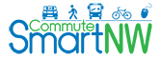 |  | 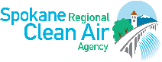
CommuteSmartNW.org | Providence.org | SpokaneCleanAir.org

Text Only - Subject: Score a Clean Air BINGO this Summer!
Get ready to breathe easier and win fantastic prizes with Clean Air BINGO
this July, August, and September! In partnership with the Spokane Regional Clean Air Agency, we're making clean air fun and rewarding.
Play & Win: Every conscious choice you make for cleaner air, from carpooling to using electric yard equipment, helps, and when you use a commute option, you could WIN some fantastic prizes!
Monthly Grand Prize: $500 Cordless Electric Lawnmower
Monthly Prizes: YETI Hopper Flip Soft Cooler + State Park Discover Pass
Weekly Prizes: Hiawatha Trail Experience, Sunglass Hut Gift Card, Silverwood Theme Park Passes, Lake Coeur d'Alene Cruise Tickets, Wonderland Family Fun Center Gift Card!
First-Time Participants: $25 Amazon Gift Card (50 winners/month!)
Workplace Prize: $25 Amazon gift card!
Ready to clear the air and win together? Learn more by contacting me <name>, your ETC, or go online to CommuteSmartNW.org and sign up using the worksite passcode <number>.
Learn About Bad Ozone! While you're making efforts for cleaner air, it's a great time to understand the “bad" ozone. Unlike the protective ozone layer high above us, ground-level ozone is a harmful air pollutant that forms on hot, sunny days from vehicle exhaust, industrial emissions, and other sources. It can impact on our respiratory health and is a key component of smog! CommuteSmartNW.org Providence.org SpokaneCleanAir.org

Subject: Check those squares off!
Wildfire smoke isn’t just a nuisance — it contains harmful particles and gases that can affect everyone’s health, especially those most vulnerable. The good news? There are simple steps you can take right now to prepare. Here’s how to get started:
Tune Up Your HVAC: Make sure your home’s cooling system is ready.
Create a Cleaner Air Room: Designate one room in your home—like your bedroom or living room—as your clean air space.
Stay Informed: Air quality can change rapidly during wildfire season.
Stay Ready - SmokeReadySpokane.org: local info, tips, and tools in one easy place.
Have you had a chance to score a Clean Air BINGO yet? It’s easy, simply making conscious choices for cleaner air, like carpooling or using electric yard equipment!

Don’t forget, when you use a commute option, you could WIN some awesome prizes!
- Monthly Grand Prize: $500 Cordless Electric Lawnmower
- Monthly Prizes: YETI Cooler + State Park Pass
- Weekly Prizes: Hiawatha Trail, Sunglass Hut, Silverwood, Lake Coeur d'Alene Cruise, Wonderland Family Fun Center!
- First-Timers: $25 Amazon Gift Card (50 winners/month!)
Worksite Prize: $25 Amazon Gift Card
Ready to clear the air and WIN, contact me <name>, your ETC or visit CommuteSmartNW.org and sign up using worksite passcode <number>.
CommuteSmartNW.org | Providence.org | SpokaneCleanAir.org

Subject: (Teleworkers) Score a Clean Air BINGO this Summer!
 |  | Learn About Bad Ozone! While you're making efforts for cleaner air, it's a great time to understand "bad" ozone. Unlike the protective ozone layer high above us, ground-level ozone is a harmful air pollutant that forms on hot, sunny days from vehicle exhaust, industrial emissions, and other sources. It can impact on our respiratory health and is a key component of smog!
Get ready to breathe easier and win fantastic prizes with Clean Air BINGO this July, August, and September! In partnership with the Spokane Regional Clean Air Agency, we're making clean air fun and rewarding.
Play & Win: Every conscious choice you make for cleaner air, from carpooling to using electric yard equipment helps, and when you use a commute option, you could WIN some fantastic prizes!
- Monthly Grand Prize: $500 Cordless Electric Lawnmower
- Monthly Prizes: YETI Hopper Flip Soft Cooler + State Park Discover Pass
- Weekly Prizes: Hiawatha Trail Experience, Sunglass Hut Gift Card, Silverwood Theme Park Passes, Lake Coeur d'Alene Cruise Tickets, Wonderland Family Fun Center Gift Card!
- First-Time Participants: $25 Amazon Gift Card (50 winners/month!)
Ready to clear the air and win together? Learn more by contacting me <name>, your ETC, or go online to CommuteSmartNW.org and sign up using the worksite passcode <number>.
CommuteSmartNW.org | Providence.org | SpokaneCleanAir.org

