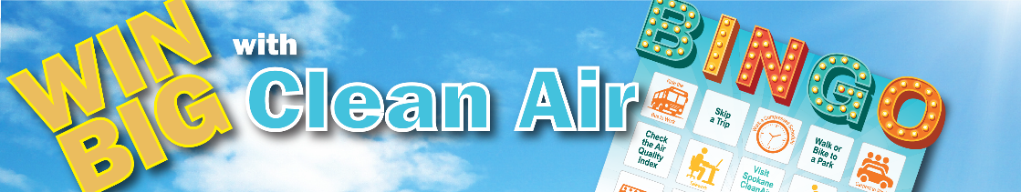
RULES OF THE GAME
- This is your game. You choose the patterns to win. A simple diagonal, vertical, horizontal or any variation shown below:
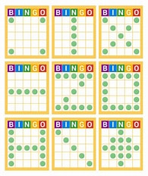
- Bingo prizes will be provided from Commute Smart NW (shown below) as well as Spokane Regional Clean Air Agency. Participants can win one BINGO prize a month in July, August and September. Prizes can be picked up at the ETC Summer Celebration on July 16th or from the Commute Smart NW office the week of July 7th. Arrangements must be made with Linda Radford, if picking up from our office.
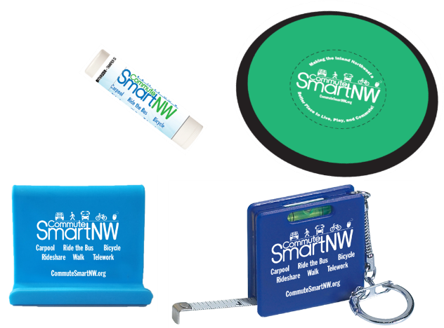
- Monthly winners of the $25 Amazon gift card can be chosen from winning cards or through the winner selector on the commute calendar.

- Any questions, please reach out to Linda Radford, lradford@spokanecounty.gov.

