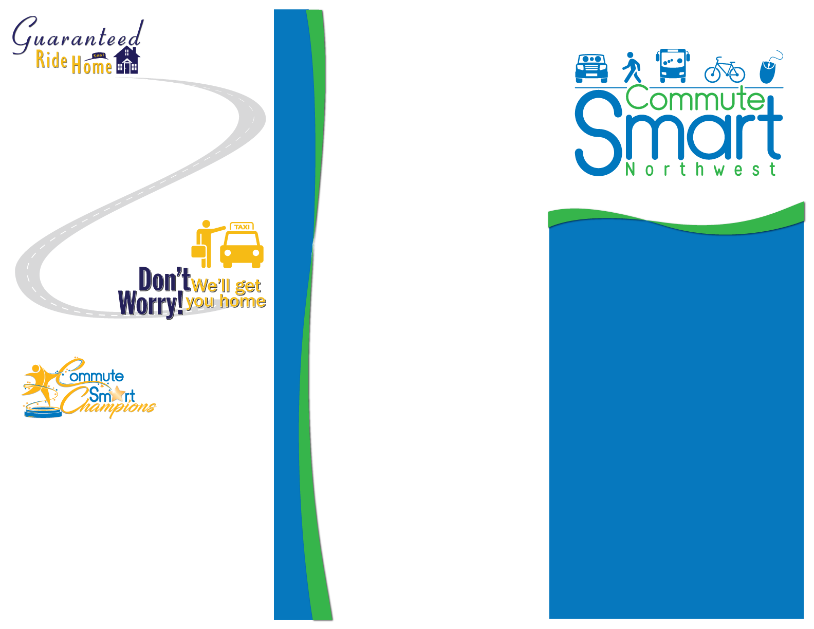

Program

A Bit about CTR…

(Company name) has joined **Spokane County’s GRH Program** to assist our employees who choose a commute alternative such as carpooling, walking, bicycling, or riding the bus to work. If you get to work using a commute alternative, or if you’ve just considered it, your worries about getting home in case of an emergency are over! By using a commute alternative to get to work that day you’re eligible. Contact (ETC’s name), ETC, to arrange for your ride home. If an emergency comes up during working hours – the illness of a family member, unexpected overtime, or a carpool partner who becomes ill at work – you can use the GRH program to get home. It’s fast, easy and free!

The **Commute Trip Reduction** (CTR) Law was implemented by the Washington State Legislature in 1991 and was updated in 2006 to the CTR Efficiency Act. The intent of the CTR law is to improve air quality, reduce traffic congestion and reduce fuel consumption.

The law requires “Affected Employers” in Washington State to develop CTR programs to encourage employees to use a commute alternative to work rather than driving alone. An “Affected Employer” is one with 100 or more full-time employees who are scheduled to begin work between 6 and 9 a.m., who work 35 or more hours per week and the job, is intended to last at least 12 continuous months. A designated Employee Transportation Coordinator helps to implement the program and provides employees with transportation choices and information.

Get More Out of  
Your Commute!

* Save Money
* Reduce Stress
* Enjoy Social Time
* Improve Air Quality

Employee Recognition Program

Learn More about Your Commute Options

There are many options available to commuters today and there are many tools to help find a commute option that’s right for you. Remember, using a commute alternative doesn’t have to be all or nothing, even if you’re only using a commute alternative one day a week you’re still making a difference! And you don’t have to stick with just one type of commute; ride your bike or walk to a park and ride and take the bus from there or mix it up and carpool one day and walk to work the next!

Giving credit, where credit is due! This Spokane County Commute Trip Reduction recognition program is designed to spotlight those employees who go the distance when it comes to using commute alternatives such as carpooling, walking, bicycling, vanpooling or riding the bus. The Way to Go Awards Recognition program also helps to bring awareness to the importance of commute trip reduction as well as the benefits.

Being part of the Spokane County CTR program, <company> can nominate any employee who displays dedication and commitment to the use of a commute alternative. If selected as a quarterly winner, they will be invited to a CTR lunch as a guest of honor where they will be presented with a Way to Go Award!

For more information, please contact me

(Name)

Your Employee Transportation Coordinator at (phone number) or (Email Address)

**Work-site | Date**

**www.CommuteSmartNW.org**

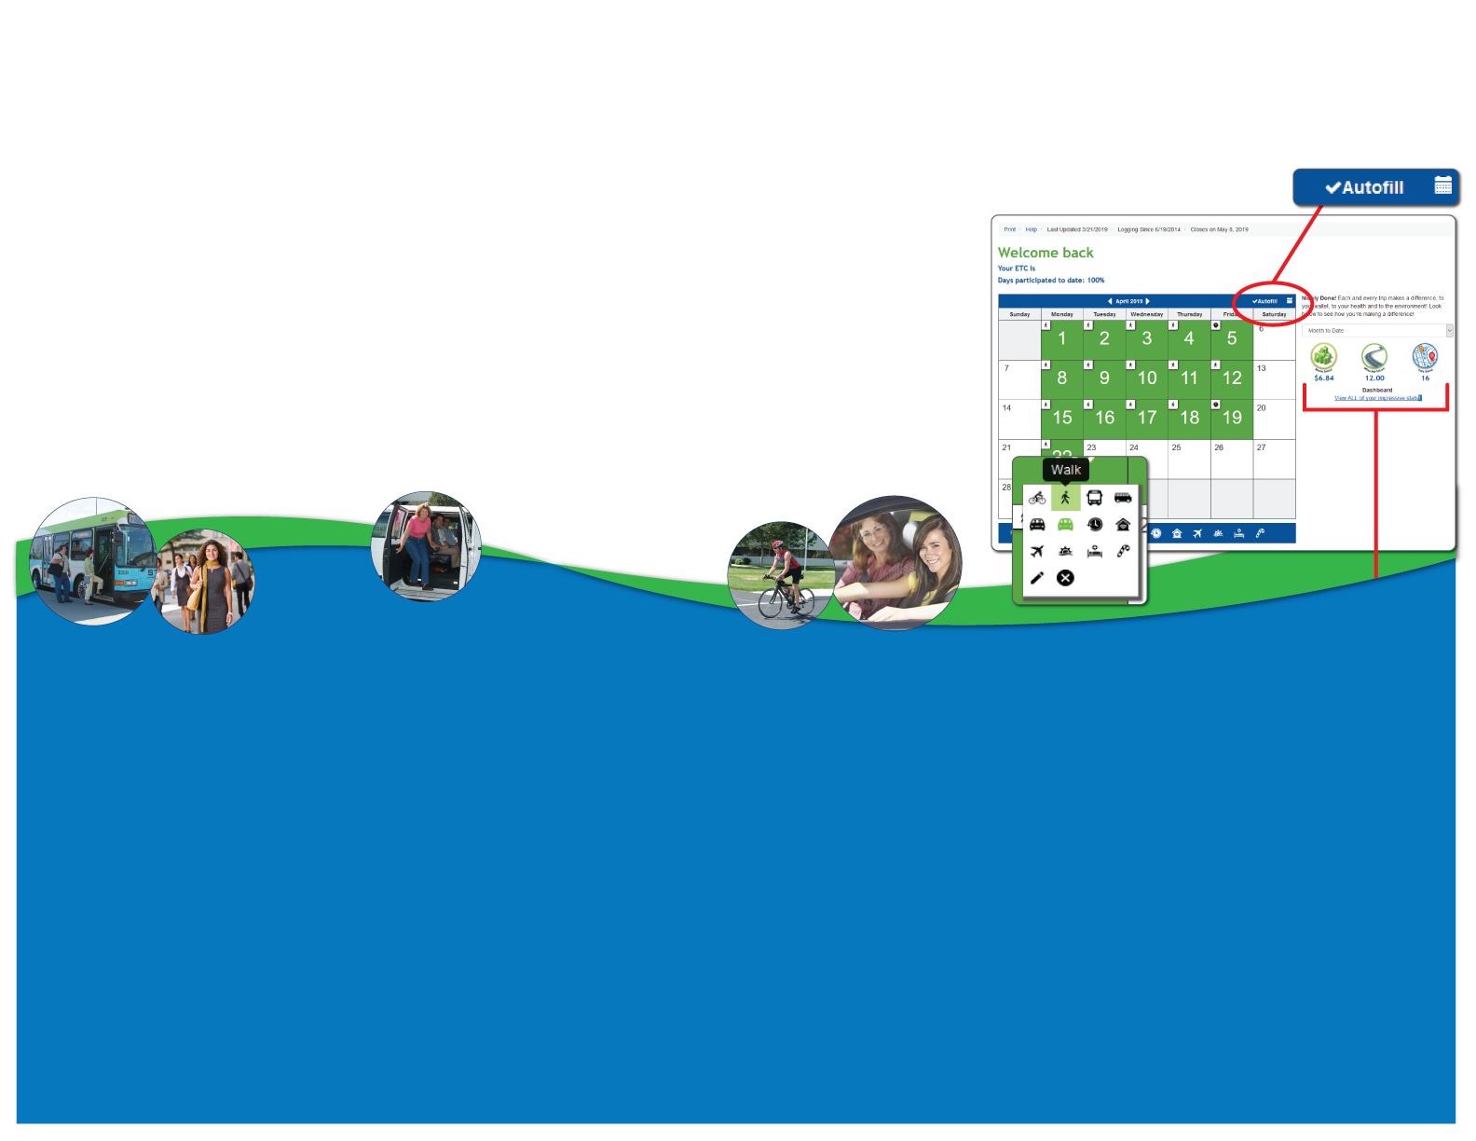

Quick and convenient drop down menu allows you to select your mode.

Don’t have a lot of time, no problem! The commute calendar features a super easy auto fill feature! You can also wait and fill your calendar out at the end of the month!

Mode legend allows for quick reference.

Learn how you make a difference! At the bottom of your commute calendar are your own personal stats that let you know how your commute is reducing pollution and helping traffic congestion!

(Your work site) encourages all employees to find alternatives to driving alone as often as possible.

(Your work site) offers various promotions throughout the year to encourage employees to try alternative modes of transportation.

All employees who participate in these campaigns will be eligible for prize drawings. Simply fill out your on-line calendar **at CommuteSmartNW.org**.

To learn more visit **www.CommuteSmartNW.org**  or contact me, (name), your ETC at (phone number) or (email address).

Now, it's easier than ever to track your daily commute on-line. By filling out your commute calendar on-line, you will automatically be entered into Commute Smart NW Campaigns and be eligible to win other great prizes.

To register, visit www.CommuteSmartNW.org and create a new user profile using worksite passcode (enter your passcode here). Once you’re registered, you can start tracking your daily commute. The calendar is your entry into contests and helps me, your Employee Transportation Coordinator track participation and report results. It’s fun and easy, get started today!

Quick and Easy On-Line CTR Tracking Calendar

Ready to Get Started?  
Finding the right carpool, vanpool, walking/biking buddy or transit route has never been so easy!

**CommuteFinderNW.com** is a free on-line commute alternative matching service powered by Spokane Transit in coordination with the Commute Smart Northwest. It provides you with immediate results of others who are interested in sharing their commute. If there’s not a match, you can get bus route and park and ride information.

It’s simple to use too! Go to **CommuteFinderNW.com** and click on “Join”. When prompted be sure to type our company name (worksite name) and then fill out your commute information, or you can contact me at (number) and I can help sign you up as well!

Don’t Miss Your Chance to WIN!

There are many benefits to using a commute alternative, here are just a few:

Our health; people who carpool or vanpool enjoy more social interaction and leisure time. The same can be said for people who ride the bus, it’s also a great opportunity to catch up on your reading! Commuters who choose active transportation such as walking or bicycling, enjoy better mental and overall physical health as well.

Another benefit is the cost savings; people who use a commute alternative save money on gas, vehicle maintenance and parking fees. I’m sure you can think of better places to spend that hard earned money! And of course there’s the environment; the use of commute alternatives helps to reduce traffic congestion, carbon emissions and fuel consumption.

(List ONLY the elements you offer your employees)

* On-site Employee Transportation Coordinator (ETC)
* Preferred parking for carpoolers and vanpoolers
* Subsidies for transit passes
* Covered bicycle parking
* Showers and/or clothes lockers available for bicyclists & walkers
* Flex-time for bus riders and vanpoolers
* Guaranteed Ride Home in case of emergencies
* Internal ridematching services
* On-site ATM
* Cafeteria and post office services
* Employee recognition
* CTR campaign and prize giveaways
* Financial and prize incentives

Take Advantage of our Commute Trip  
Reduction Program

The Benefits of Using a Commute Alternative